Bug_id_01
Bug Description:
On the Leads page, searching for an incorrect or non-matching term like "co" still shows the lead "Ali" in the results, even though it should show no results or an empty state. The search filter is not working correctly.
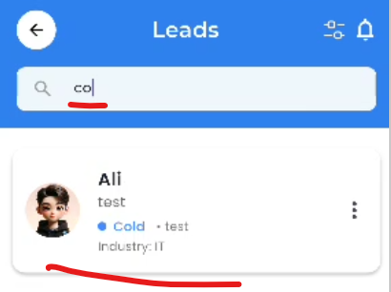
Bug_id_02
Bug Description:
On the Leads page, after opening the keyboard via the search field, tapping elsewhere on the screen fails to dismiss the keyboard. This forces the user to use the device's back button, leading to a poor user experience and interaction flow disruption.
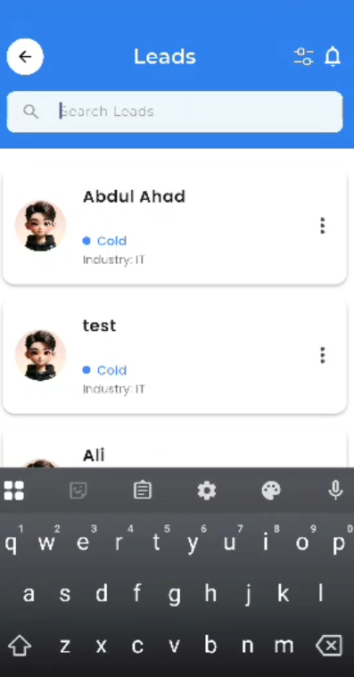
Bug_id_03
Bug Description:
On the Leads page, the Industry dropdown menu in the filter only shows three options: IT, Finance, and Health. This is too limited and should include more industry options such as Education, Retail, Manufacturing, etc., to properly categorize leads.
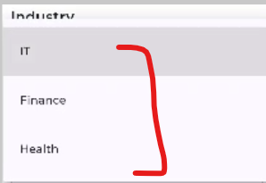
Bug_id_04
Bug Description:
On the Leads page, the Business dropdown menu only contains generic placeholder options: Business A, Business B, Business C. There is no option for users to add or select their own business if it is not listed. This makes the filter unusable for real business selection.
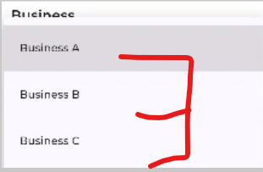

Bug_id_05
Bug Description:
On the Leads page, the filter function does not work. Selecting any industry, business, lead status, or date range and clicking "Apply" does not filter the leads list. The filter has no effect on the displayed results.
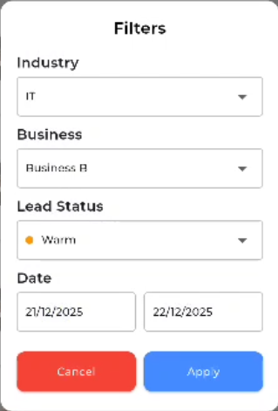
Bug_id_06
Bug Description:
On the Leads page, the notification icon (bell/symbol) is non-functional. Tapping it does not open any notification panel, dropdown, or navigate to a notification screen.
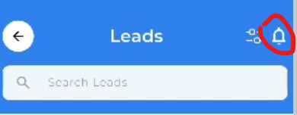
Bug_id_07
Bug Description:
The page shows the title "Leads" but the URL or expected page name should be "Lead Status" based on the content and context. This naming inconsistency can confuse users about the page's purpose.
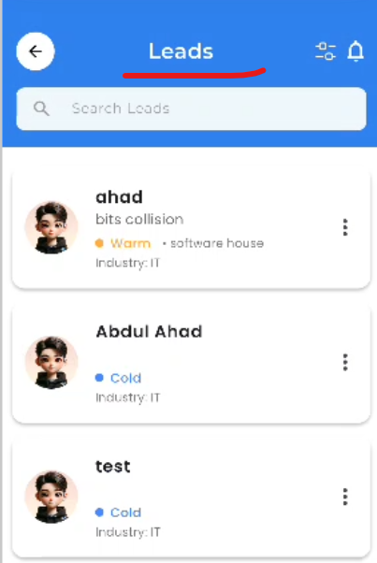

Bug_id_08
Bug Description:
When clicking on a lead, the detail popup shows all information (company, phone, email, etc.) in a poorly formatted layout with improper spacing, alignment, and visual hierarchy, making it difficult to read and use.
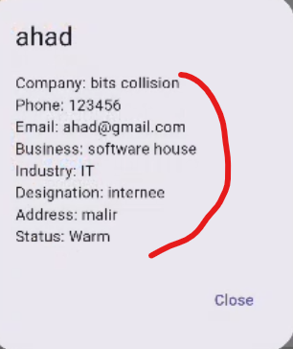
Bug_id_09
Bug Description:
The WhatsApp and Call icons inside the lead action menu are non-functional. Tapping them does not initiate a WhatsApp message or phone call to the lead's contact number.
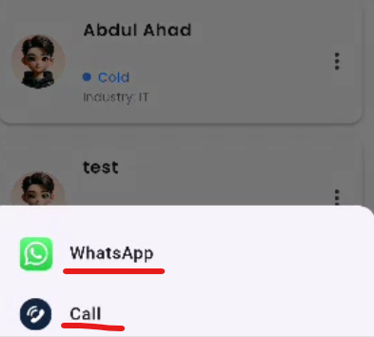

Bug_id_10
Bug Description:
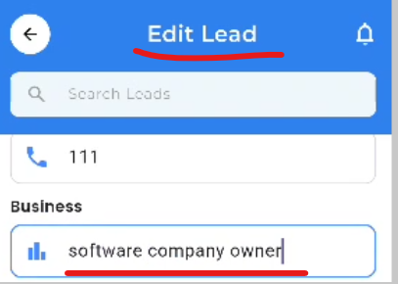
After editing a lead's details and receiving the "Lead updated successfully!" message, the lead information does not actually change. The updated data is not reflected in the lead list or details, making the edit feature non-functional.

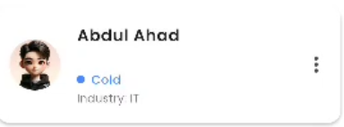

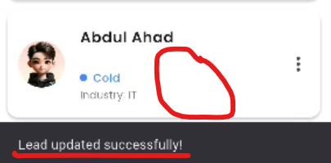

Bug_id_11
Bug Description:
Clicking the delete option for a lead shows the message "Delete failed" but lead is not deleted from the list, making the delete feature non-functional.
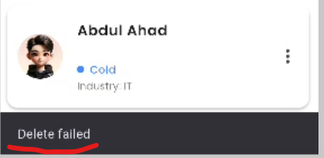
Bug_id_12
Bug Description:
The Lead Status filter only shows three options: Hot, Warm, Cold. It is missing the "Dead" status option, which is required for complete lead status filtering.
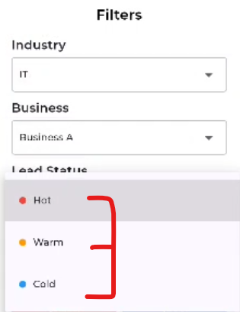
Bug_id_13
Bug Description:
The filter popup cannot be closed by tapping outside the popup area. The user must click the Cancel button to close it, which is not standard behavior and reduces usability.
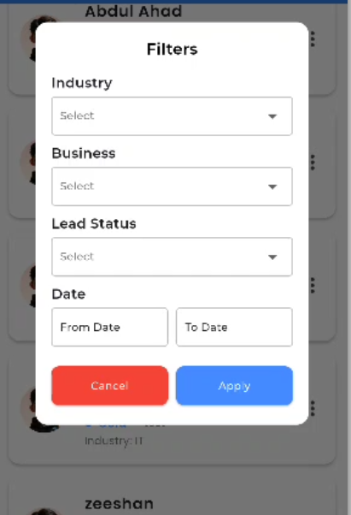

Bug_id_14
Bug Description:
The filter popup cannot be closed by tapping outside the popup area. The user must click the Cancel button to close it, which is not standard behavior and reduces usability.

